Design Document for Saftech Fonez

By Sammar Tahir and Usman Sattar

Contents

Introduction 3

System Requirements 3

Technology Used and Why 4

Design Methodology 5

Features of the Implementation 7

Limitations and Known Bugs 8

Testing Plans 8

Recommendations for Future Development 8

Conclusions 8

# Introduction

Saftech Fonez is an eCommerce website. This website is built with angular and node.js. We offer customers a selection of mobile phones and accessories to purchase. Customers can purchase anything from our website using a safe and secure PayPal payment service. Our website can be run on many devices including mobile phones, laptops, tablets etc... We came up with this idea from an existing and running business. This project was a perfect example to make an eCommerce website that would be used not only as a project but business use also. This multi-user friendly application is aimed at people who are regular online shoppers and who need to stay up to date with technology news.

This is an application with realism, which can be used and accessed every day and any time. We want anyone to access this and shop with us in the future. There are many online shops on the online market, but what makes us different? We offer our products and services to customers at low cost competitive prices. Attracting customers with our eye-catching homepage and low-cost prices. 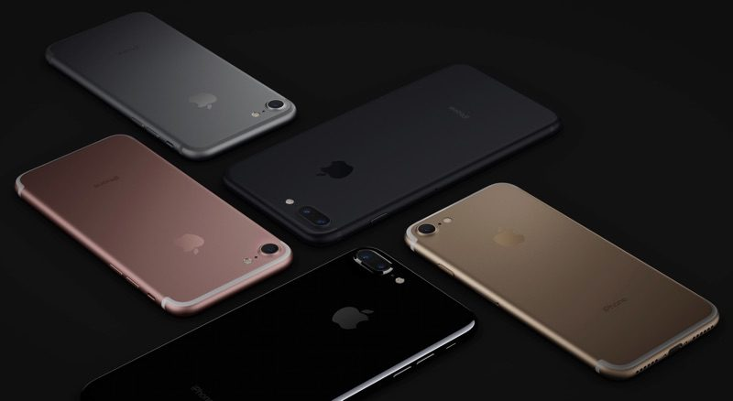

# System Requirements

This is what we recommend you have in order to run the application:

|  |  |
| --- | --- |
| **Operating system** | Windows 95 or NT or superior |
| **CPU** | Pentium processor at 90 MHz or higher |
| **Memory** | 16 MB RAM |
| **Hard drive** | 80 MB available in the hard disk |
| **Browser** | Chrome or Firefox |
| **Graphics hardware** | DirectX 3.0 or higher |
| **Applications** | Visual Studio Code or Command Prompt |

# Technology Used and Why

We decided to use angular for this project since we have pretty good experience with it. Angular has loads of online support and providers to help build any web application. HTML is a declarative language which is more intuitive and less convoluted than defining the interface procedurally in JavaScript.

As form of payment and user information we went with PayPal as the service is very reliable and secure. PayPal also has a good relationship with online users who are more likely to pay via PayPal knowing their information is safe. We were originally going to store our user's information locally, but we thought users might hesitate to give us personal banking information. PayPal also gives us a delivery address to use so we know where to deliver to without having to worry about storage for each user address.

MySQL was used to store our phone information. We were able to find online installs for MySQL to set up our storage. We choose MYSQL for storage because it was easy to run queries and understand we had to pull information from We found resources online helping us through the problems we came across our application.

Choosing an IDE wasn’t difficult for us. We went with Visual Studio Code because built-in support for Node.js. VS Code allows us to work on light coding stuff like CSS for webpages with ease while tackling bigger code for servers and storage going on behind the scenes of our website. Live Share was one of the extensions we used in VS Code to help us work with on our code live simultaneously.

Finding the perfect place to host our server was an issue as we didn’t know much about hosting data on servers. We have used mongoDB before, but we didn’t want to change our MYSQL database to suit mongoDB. We went to Amazon Web Services in the end because it was the only server, we were familiar with.

# Design Methodology

##### Homepage

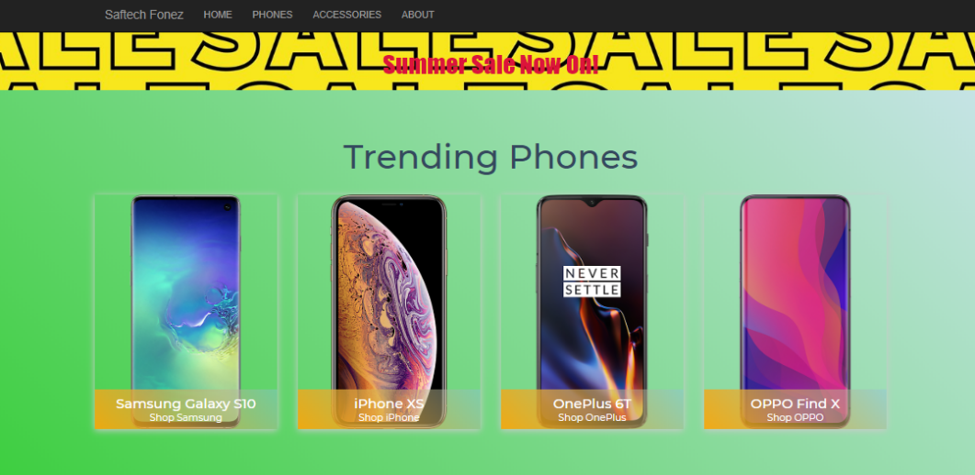

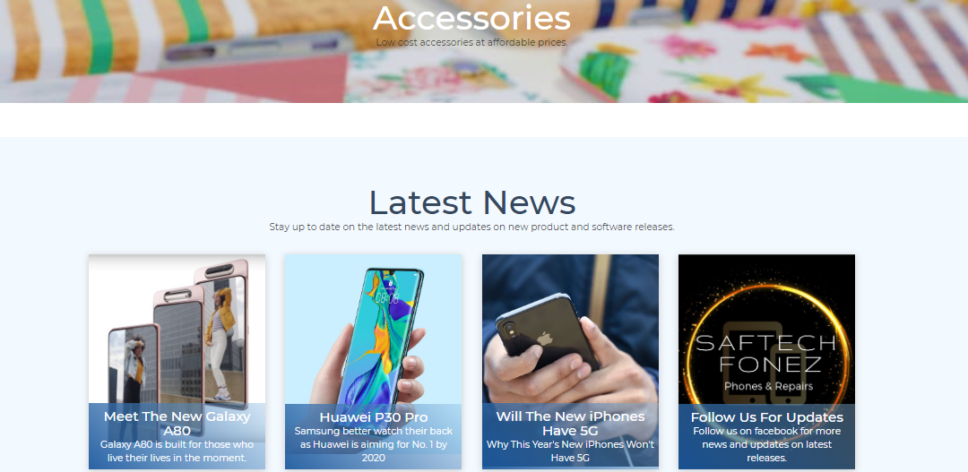

This was the design we went with for our home page. It was simple but is very effective at catching the eye of users.

The page is split up into three main colums. We thought the page having proper divders could help people easily find what they were looking for.

Footer



We didn’t spend much time on the footer we just got the design inspiration from other websites. We thought that having links to social media should be good way to keep interactions with users

##### Phones & Accessories

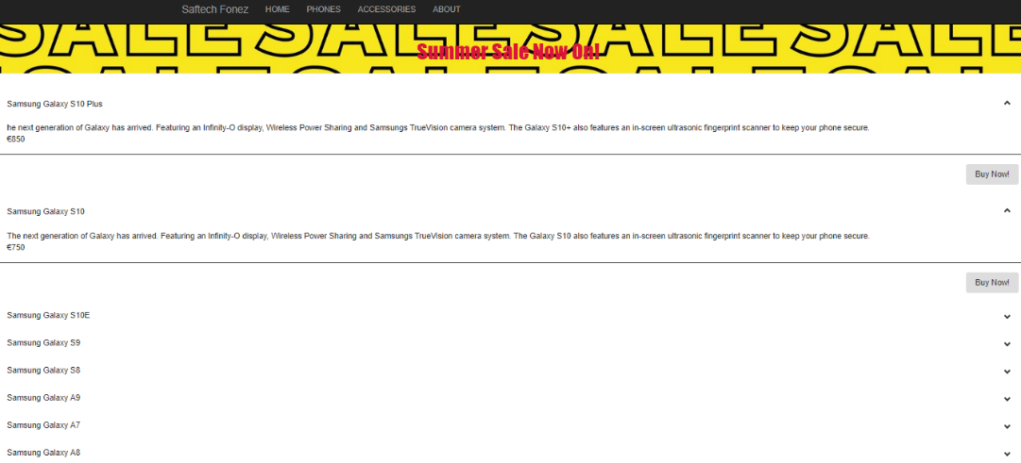

It was hard to get the information to display from the server to the page, so we wanted to have the 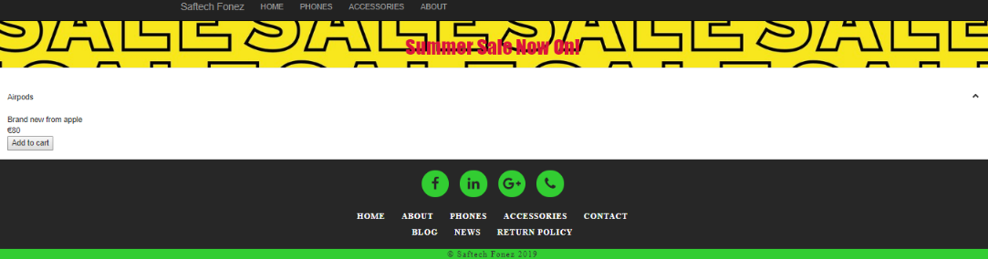just have the information displayed as a list view

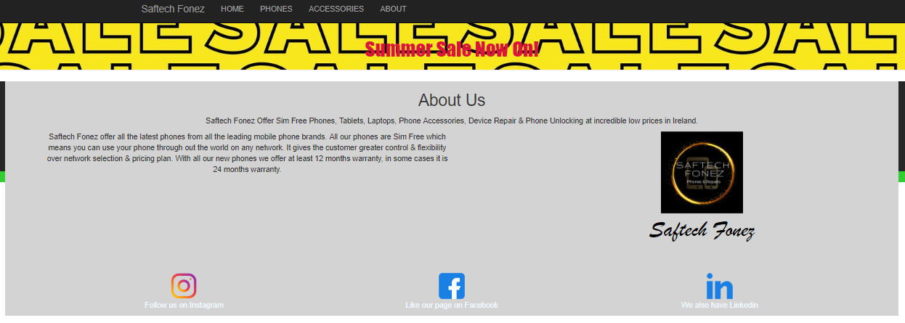

About us has basic information about the company and some links on to get in touch through social media on any future questions a user might have about a product

# Features of the Implementation

**PayPal Payment**

One of our amazing features we have implemented in our website is PayPal checkout. Anyone who wishes to purchase any product will pay through PayPal. This is to gain customer trust and customer knows it is a secure payment option.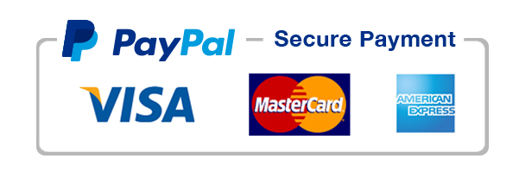

**AWS Server**

We implemented out database of products on the cloud server. We used Amazon Web Services for storing information on the cloud. We used this server over Azure because it is secure and reliable. Also, Amazon has one of the best website hosting services which we can use in the future.

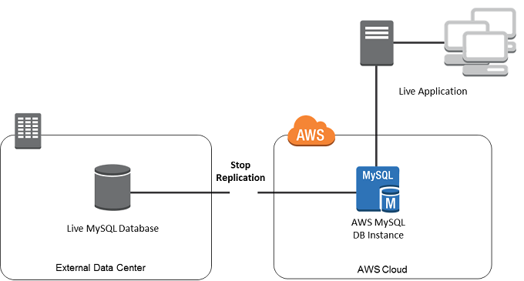

**MySQL**

We created a database on MySQL which was implemented with the website showing the products and the inventory system. Later we decided to have database globally stored where anyone can read It and access it on our website. After creating the products and testing out the database, we stored the database to cloud storage on AWS as described above.

# Limitations and Known Bugs

* Blobs or Images not appearing in our database for our products. Therefore, we only have product description and pricing. Customer can’t view the item currently.
* Different payment methods. Customers who do not have PayPal can’t purchase our products therefore we need stripe payment option and implement it in our website in the future to increase sales.

# Testing Plans

* Tested to see if the main core functions of website worked such as every page was able to link to one another and clicks lead to some sort of link
* Tested the MYSQL file to see if worked fine and queries would run without throwing mismatch information
* Last main tests were to check if the database could connect to the app while being on AWS.

# Recommendations for Future Development

Future development for Saftech Fonez would be firstly to have it hosting properly on air for everyone to view our products and services. We would also like to add secure payment methods and a shopping cart page to add products to their cart and view their basket. A slight difference we shall make to the products page would be having multiple images, so customers can view our products.

# Conclusions

We have learnt a lot from when we started this project. We didn’t fully understand how much time goes into preparing to do project so basic. This project helped us realize that group work requires an extreme amount of communication and patience.